Department of Veterans Affairs

VHA Point Service (Kiosks) Phase II

Enhancement VPS*1.0*14

**Technical Manual**



Delivery Order VA118-11-D-1009

Task Order VA118-1009-0031

September 2015

Version 0.01

Revision History

| Creation Date | Version No. | Description/Comments | Author(s) | Reviewer(s) | Review Type | Issue Date |
| --- | --- | --- | --- | --- | --- | --- |
| 09/16/2015 | 0.01 | Initial draft. | Carolyn Wheless |  |  |  |
|  |  |  |  |  |  |  |
|  |  |  |  |  |  |  |
|  |  |  |  |  |  |  |
|  |  |  |  |  |  |  |
|  |  |  |  |  |  |  |
|  |  |  |  |  |  |  |
|  |  |  |  |  |  |  |
|  |  |  |  |  |  |  |
|  |  |  |  |  |  |  |
|  |  |  |  |  |  |  |
|  |  |  |  |  |  |  |
|  |  |  |  |  |  |  |

Table of Contents

1 Orientation 1

1.1 How to Use this Manual 1

1.2 Intended Audience 1

1.3 Legal Requirements 1

1.4 Disclaimers 1

1.5 Documentation Conventions 1

1.6 Commonly Used Terms 2

1.7 Technical Information Online 3

1.8 Help Prompts 3

1.9 Data Dictionary 3

1.10 Assumptions 3

1.11 References 3

2 Introduction 4

2.1 Product Overview 4

2.2 Namespace Conventions 4

3 Implementation and Maintenance 4

3.1 Site Parameters 4

3.2 Health Summary Configuration 4

3.3 Create New Clinical Survey Questionnaire Patient Data Object 9

4 Files 14

4.1 VistA M Server Files 14

4.2 VPS*1.0*14 Modified VPS Data Files 14

5 Global Translation, Journaling and Protection 15

6 Routines 15

6.1 VPS*1.0*14 RPCs 16

6.2 Detailed VPS*1.0*14 RPC Information 16

7 Exported Options 16

8 Archiving and Purging 16

8.1 Archiving 16

8.2 Purging 16

9 Callable Routines 16

10 External Interfaces 17

11 External Relations 17

12 Internal Relations 17

13 DBIA Agreements 17

13.1 DBIA Agreements – Custodial Package 17

13.2 DBIA Agreements – Subscriber Package 18

14 Package-wide Variables 18

15 SAC Exemptions 18

16 Software Product Security 18

16.1 Security Management 18

16.2 Mail Groups and Alerts 18

16.3 Remote Systems 18

16.3.1 Connections 18

16.3.2 Remote Data Views 18

16.4 Interfaces 18

16.5 Electronic Signatures 19

16.6 Security Keys 19

16.7 File Security 19

16.8 Official Policies 19

17 Acronyms and Glossary 19

17.1 Acronyms 19

17.2 Glossary 20

Tables

Table 1: Commonly Used VPS*1.0*14 Terms 2

Table 2 VistA M Server Files Accessed by VPS*1.0*14 14

Table 3 VPS VistA Routines 15

Table 4 VPS*1.0*14 RPCs - Tags and Routines 16

Table 5: List of Acronyms 19

Table 6: Glossary 20

# 

# Orientation

## How to Use this Manual

This manual provides instructions on the use of VPS*1.0*14 remote procedure calls (RPC) to access Veterans Health Information Systems and Technology Architecture (VistA) as a data source for VHA Point of Service (Kiosks).

## Intended Audience

The intended audience of this manual is the following stakeholders:

* Product Development (PD) VistA legacy development teams.
* Information Resource Management (IRM) system administrators at Department of Veterans Affairs (VA) sites who are responsible for computer management and system security on VistA M Servers.
* Information Security Officers (ISOs) at VA sites responsible for system security.
* Health Product Support (HPS) Information Technology (IT) Specialists who provide application support to VA end-users.

## Legal Requirements

There are no special legal requirements involved in the use of VPS*1.0*14 RPCs.

## Disclaimers

This manual provides an overall explanation of VPS*1.0*14 functionality. This guide does not attempt to explain how the overall VistA programming system is integrated and maintained.

DISCLAIMER: The appearance of any external hyperlink references in this manual does not constitute endorsement by the Department of Veterans Affairs (VA) of this Website or the information, products, or services contained therein. The VA does not exercise any editorial control over the information you may find at these locations. Such links are provided and are consistent with the stated purpose of this VA Intranet Service.

## Documentation Conventions

The following symbols are used throughout this document to alert the reader to special information.

 **NOTE/REF:** Used to denote general information including references to additional reading material.

**CAUTION / RECOMMENDATION / DISCLAIMER:** Used to caution the reader to take special notice of critical information.

Snapshots of computer online displays (screen captures) and computer source code are shown in non-proportional font and are enclosed within a box. User responses to displayed prompts are bold italic typeface. Software reserved words are displayed in bold font.

References to “<Enter>” within the screen captures indicate that the user should press the <Enter> key on the keyboard. Other special keys are represented within < > angle brackets and indicate the user should press the indicated key on the keyboard. For example, <PF1> directs the user to press the PF1 key on the keyboard.

The following conventions are used to display test data:

* Social Security Numbers (SSN) for test patients are prefixed with five zero digits e.g. 000009999.
* Patient names are formatted as [Application Name]PATIENT,[N] e.g. VPSPATIENT, ONE.
* User names are formatted as [Application Name]USER[N] e.g. VPSUSER, ONE.

 This guide refers to the M programming language as M. Under the 1995 American National Standards Institute (ANSI) standard, M is the primary name of the MUMPS programming language, and MUMPS is considered an alternate name.

## Commonly Used Terms

Table 1: Commonly Used VPS*1.0*14 Terms

| Term | Description |
| --- | --- |
| Client | A single term used interchangeably to refer to a user, the workstation (i.e., PC), and the portion of the program that runs on the workstation. |
| Component | A software object that contains data and code. A component may or may not be visible. |
| GUI | The Graphical User Interface application that is developed for the client workstation. |
| HL7 | Health Level Seven real-time messaging protocol. |
| HLO | Health Level Seven Optimized refers to the VA implementation of the HL7 protocol in VistA. |
| Host | The term Host is used interchangeably with the term Server. |
| Server | The computer where the data and the RPC Broker remote procedure calls (RPCs) reside. |
| TCP | Transmission Control Protocol is a communications protocol used to provide end-to-end connectivity between hosts. |
| IP | Internet Protocol is a communications protocol that specifies host network addresses. |

## Technical Information Online

Project documentation for VPS Kiosks may be found in the Technical Services Project Repository (TSPR). Other online technical information from M Server-based software file, routine and global documentation may be generated using Kernel, MailMan and VA FileMan utilities.

## Help Prompts

Help prompts are provided for each field in the VPS*1.0*14 FileMan data files. Additional online help is provided in the Health Summary technical manual and user guide available on the VistA Document Library (VDL) to assist in VPS*1.0*14 Health Summary report configuration..

## Data Dictionary

Technical information on VistA M Server-based files is stored in the VA FileMan Data Dictionary. The VA FileMan List File Attributes option on the Data Dictionary Utilities submenu may be used to view the attributes of VistA M Server files.

## Assumptions

This guide is written with the assumption that the reader is familiar with:

* Kernel – VistA M Server software
* Remote Procedure Call (RPC) Broker – VistA Client/Server software
* VA FileMan data structures and terminology – VistA M Server software
* Microsoft Windows
* M programming language

## References

The following references support the reader’s understanding of the operation and functioning of VPS*1.0*14:

* *VPS*1.0*14 Technical Guide (this guide)*
* *RPC Broker Release Notes*
* *RPC Broker Developer’s Guide*
* *RPC Broker Systems Management Guide*
* *RPC Broker TCP/IP Supplement, Patch XWB*1.1*35 and XWB*1.1*44*
* *RPC Broker Technical Manual*
* *RPC Broker User Guide*
* *Department of Veterans Affairs Veterans Point Service (VPS) FY15 OIT BRD Business Requirements Document, version V4, May 2015.*
* *VHA Point of Service (Kiosks) Phase II Installation Guide For VPS Combined 4, 5, 3 Build 1.0 (January 2015)*
* *VPS Technical Manual*

These references may be downloaded from the [VA Software Document Library (VDL) Website](http://www.va.gov/vdl/).

# Introduction

The *VPS*1.0*14 Technical Guide* provides descriptive information and instruction on the use of VPS*1.0*14 remote procedure calls (RPCs) within VA's Veterans Health Information Systems and Technology Architecture (VistA) environment. This document is intended for systems managers—Information Resource Management (IRM) personnel who are responsible for implementing and maintaining this software, application programmers, and developers. It acquaints system managers with the software structure and functionality of the VPS RPC routines and files that comprise this software.

## Product Overview

VPS*1.0*14 provides RPCs that extends VetLink integration with multiple VistA packages, and provides the capability to store patient survey data. The effort consists of two parts, the Clinical Screening Questionnaires (CSQ) Phase 2 and Enhanced VPS Get Patient Demographics RPC-Phase 2.

* The CSQ effort will enhance the data collection methods started in Phase 1 by creating a suite of CSQ entities that can be viewed at the enterprise level and queried against to offer analytical output.
* The Enhanced VPS Get Patient Demographics RPC-Phase 2 effort will look to obtain more clinically relevant information from VistA to facilitate use by clinical staff.

## Namespace Conventions

VPS is the namespace assigned to VPS*1.0*14.

# Implementation and Maintenance

The *VPS*1.0*14 Installation Manual,* available from the VA VistA Document Library, provides detailed information on the installation of the VPS*1.0*14 RPCs and configuration requirements.

## Site Parameters

No site specific parameters are provided or required for VPS*1.0*14.

## Health Summary Configuration

VPS*1.0*14 provides the capability to report on the clinical survey questionnaire (CSQ) activity of clinic patients in CPRS using Ad Hoc Health Summary (HS) reports.

Two default Ad Hoc HS reports, CSQ HS TYPE and CSQ HS CALC TYPE were created during the VPS*1.0*5 post-install process. Data for these Ad Hoc HS reports are populated from the default VPS CSQ PDO object, which was also created during the VPS*1.0*5 post-install process. Please see the VHA Point of Service (Kiosks) Phase II Installation Guide For VPS Combined 4, 5, 3 Build 1.0 (January 2015) for detailed instructions on creating the VPS Ad Hoc HS reports.

To execute the Ad Hoc HS reports CSQ HS TYPE or CSQ HS CALC TYPE, launch CPRS and select the patient whose survey responses are to be reported. Click the Reports tab:

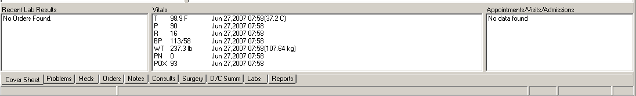

Click the plus sign to open the Health Summary Reports:

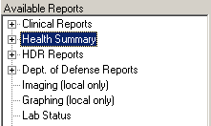

Click Adhoc Report in the Health Summary Reports list:

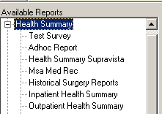

Continued on the next page.

Click on an Adhoc report name, Csq Hs Calc Type [CSQ} and then click the right-arrow, >, in the Component Selections pane.

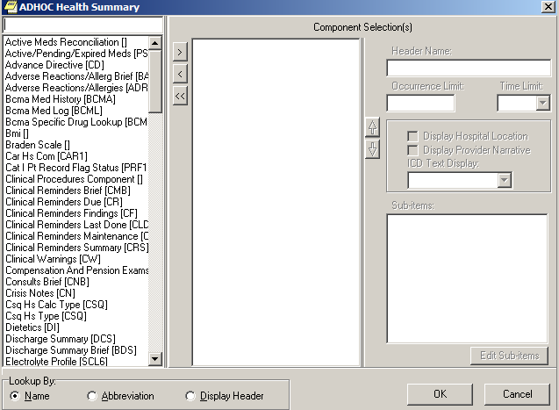

You may select multiple Adhoc reports for display. When you select either the Cs Hs Type [CSQ] or the Csq Hs Calc Type [CSQ] for reporting, you will be presented with a dialog to allow the selection of up to 3 clinical survey questionnaires to be included.

Click the CSQ name in the File Selection box, then click the right-arrow, >:

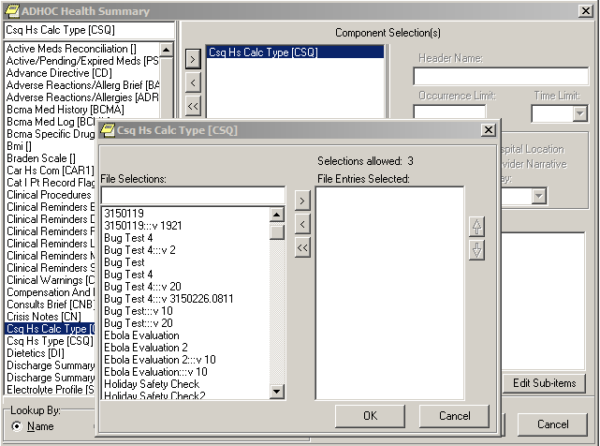

When all CSQs have been selected and appear in the File Entries Selected list, click the OK button:

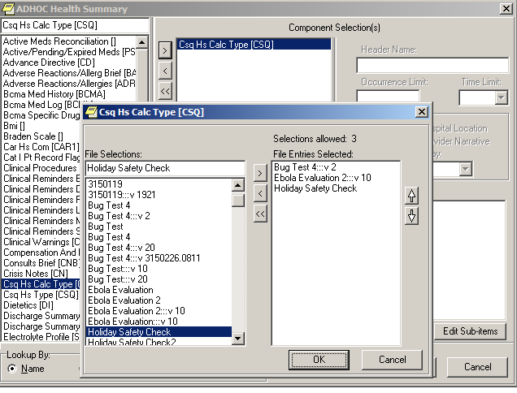

Click the OK button.

Click the OK button again to generate a report of the patient’s survey responses for the selected CSQs:

Note: If a patient responded to a CSQ multiple times during the current year, the most recent occurrences up to the occurrence limit of 5 will be included in the report.

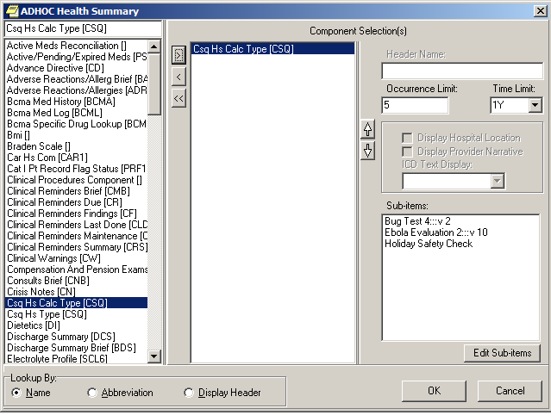

Note: The following is sample output of the CSQ HS CALC TYPE report:

| 02/26/2015 18:54  ******************** CONFIDENTIAL AD HOC SUMMARY pg. 1 *********************  XXXXX,XXX X XXX-XX-XXXX DOB: 12/26/1955  CSQ - CSQ HS CALC TYPE  ___________________________________________________________________________  BUG TEST 4:::V 2 - (max 5 occurrences or 1 year)  Patient Name: XXXXX,XXX X  Questionnaire IEN: 4  Questionnaire Name: BUG TEST 4  Date and Time Taken: FEB 25, 2015@08:11  Date and Time Last Modified: FEB 26, 2015@08:11  Questions and Answers:  What is your name? Programmer,%FOUR    - - - - - - - - - - - - - - - - - - - - -  Survey Calculated Value: VERSION Check  Value - SCORE;2F  Value - XYZ;55  ___________________________________________________________________________  ___________________________________________________________________________  EBOLA EVALUATION 2:::V 10 - (max 5 occurrences or 1 year)  No results  ___________________________________________________________________________  ___________________________________________________________________________  HOLIDAY SAFETY CHECK - (max 5 occurrences or 1 year)  No results  ___________________________________________________________________________  ------------ CSQ - CSQ HS CALC TYPE (max 5 occurrences or 1 year) ------------    No data available for BUG TEST 4:::V 2; Ebola Evaluation 2:::V 10;  HOLIDAY SAFETY CHECK  *** END ************ CONFIDENTIAL AD HOC SUMMARY pg. 1 ******************** |
| --- |

## Create New Clinical Survey Questionnaire Patient Data Object

The VPS CSQ patient data object is the default PDO for VPS clinical survey questionnaires. Additional customized PDOs may be created by the Clinical Applications Coordinator (CAC). The CAC may specify Questionnaire internal entry number (IEN) and/or Questionnaire name, the number of occurrences of the questionnaire to be included, as well as a date range to filter VPS CSQ results to be included in a CSQ PDO.

The process for creating a new CSQ PDO is described in following sample screen captures.

1. Using the TIU Maintenance Menu option, select item 2, Document Definitions (Manager)

| Select OPTION NAME: **TIU MAINTENANCE MENU** TIU IRM MAINTENANCE MENU TIU Maintenance Menu  1 TIU Parameters Menu ...  2 Document Definitions (Manager) ...  3 User Class Management ...  4 TIU Template Mgmt Functions ...  5 TIU Alert Tools  6 Active Title Cleanup Report  7 TIUHL7 Message Manager  Title Mapping Utilities ...  Select TIU Maintenance Menu <TEST ACCOUNT> Option: **2 Document Definitions (Manager)** |
| --- |

1. Select item 4, Create Objects, from the Manager Document Definition Menu.

| --- Manager Document Definition Menu ---  1 Edit Document Definitions  2 Sort Document Definitions  3 Create Document Definitions  4 Create Objects  5 Create TIU/Health Summary Objects  You have PENDING ALERTS  Enter "VA to jump to VIEW ALERTS option  Select Document Definitions (Manager) <TEST ACCOUNT> Option: **4 Create Objects** |
| --- |

1. Press the <ENTER> key at the prompt, FIRST//.

| START DISPLAY WITH OBJECT: FIRST// .............................................  ................................................................................  .......................................................................  **Objects** Feb 24, 2015@15:12:05 Page: 1 of 16  Objects  Status  1 A1C HGB A  2 A1C LAST A  3 ABD CAT SCAN A  4 ABG A  5 ACTIVE MEDICATIONS A  6 ACTIVE MEDS COMBINED A  7 ACTIVE PROBLEM A  8 ACTIVE/PENDING/EXPIRED MEDICATIONS A  9 ACTIVE/PENDING/EXPIRED MEDS I  10 ACTIVE/PENDING/EXPIRING MEDICATIONS (W/O SUPPLIES) A  11 ADMISSIONS PAST YR A  12 ALBUMIN A  13 ALBUMIN TIU OBJECT A  14 ALLERGIES WITH DETAIL A  + ?Help >ScrollRight PS/PL PrintScrn/List +/- >>>  Find Detailed Display/Edit Copy/Move  Change View Try Quit  Create Owner  Select Action: Next Screen// |
| --- |

1. Enter CREATE at the Select Action prompt as shown below. Enter a new name for your PDO. To avoid confusion with national or application default PDOs, please do not begin the PDO name with VA, VPS, or CSQ. Delete the CLINICAL COORDINATOR as the CLASS OWNER, and enter your name as the PERSONAL OWNER of the PDO.

Select Action: Next Screen// **CREATE** Create

Enter the Name of a new Object*:****<Questionnaire PDO descriptive name>***

CLASS OWNER: CLINICAL COORDINATOR// **@**

PERSONAL OWNER:**<your name> <ENTER>**

Entry added

1. After creating the new PDO object in step 2, the Object list is displayed, and the newly enter object name should appear in the list. Enter the Object number (number to the left of the name) at the Select Entry prompt.

| **Objects** Feb 24, 2015@15:23:57 Page: 2 of 16  Objects  + Status  24 ***Questionnaire PDO description name*** I  25 CBC A  26 CBC 2 A  Find Detailed Display/Edit Copy/Move  Change View Try Quit  Create Owner  Select Action: Next Screen// **D Detailed Display/Edit**  Select Entry: (24-37): **24** |
| --- |

1. The Detailed Display screen shows the basic information for the PDO object.

Enter Technical Fields at the Select Action prompt. As shown in the screen capture below. Replace the parameter placeholders *<QID>, <QNM>*, etc. in the following M code and enter the M code with applicable parameters at the OBJECT METHOD prompt.

| Technical Fields  Object Method:  + ? Help +, - Next, Previous Screen PS/PL  Basics Try Delete  Technical Fields Find Quit  Select Action: Next Screen// **TECHNICAL FIELDS**  S X=$$GETRPT^VPSSRVY3(DFN,”^TMP(“”VPSPDO1””,$J)”,”<QID>”,”<QNM>”,<FRMDT>,<TODT>,<CSQOCCU>) |
| --- |

| **Detailed Display** Feb 24, 2015@15:26:21 Page: 1 of 1  Object CAROLYN TEST    Basics  Name: ***Questionnaire PDO description name***  VHA Enterprise  Standard Title:  Abbreviation:  Print Name: ***Questionnaire PDO description name***  Type: OBJECT  IFN: 97  National  Standard: NO  Status: INACTIVE  Owner: ***your name***  Technical Fields  Object Method:  ? Help +, - Next, Previous Screen PS/PL  Basics Try Delete  Technical Fields Find Quit  Select Action: Quit// Select Action: Quit// **Technical Fields** Technical Fields  OBJECT METHOD: **S X=$$GETRPT^VPSSRVY3(DFN,”^TMP(“”VPSPDO1””,$J)”,”<QID>”,”<QNM>”,<FRMDT>,<TODT>,<CSQOCCU>)** |
| --- |

In the M code shown above, the following parameter are place holders and may be replaced with specific values or left empty:

QID The TEMPLATE ID of the desired Clinical Survey Questionnaire. This is the unique survey identifier (optional). To obtain the CSQ TEMPLATE ID do a FileMan inquiry to the VPS QUESTIONNAIRE IDENTIFIERS file #853.85. There must be quotation marks surrounding this value.

QNM The Clinical Survey Questionnaire name (optional) is the name in the VPS QUESTIONNAIRE NAME file #853.85 corresponding to a CSQ TEMPLATE ID. To obtain the CSQ name (QNM) do a FileMan inquiry to the VPS QUESTIONNAIRE NAME file #853.875. There must be quotation marks surrounding this value.

**NOTE: If both QID and QNM are omitted, all CSQs to which the patient has responded will be included in the PDO.**

**If both the QID (Questionnaire IEN) and QNM (Questionnaire Name) are provided, the QID must correspond or refer to the provided QNM. If the QID does not correspond or refer to the QNM then no CSQ survey data is returned.**

FRMDT The starting date for a date range (optional). If not provided all identified questionnaires are returned. The starting date must be entered in FileMan format, e.g. April 16,2015 in FileMan format is 3150416.

TODT The ending date for a date range (optional). If not provided all identified questionnaires are returned. The ending date must be entered in FileMan format, e.g. April 16, 2015 in FileMan format is 3150416.

CSQOCCU The number of questionnaire instances to be included in the PDO when a patient has responded to a questionnaire multiple times (optional). If not provided, all occurrences of the CSQ are returned.

Following are example OBJECT METHOD parameter settings.

1. The following OBJECT METHOD will retrieve the first three submissions of the CSQ with QID equal to 3 for a patient.

**S X=$$GETRPT^VPSSRVY3(DFN,"^TMP(""VPSPDO1"",$J)",”** **37eb0b5ea435b559e994222e2ad6bf83”,"HOLIDAY SAFETY CHECK",,,3)**

Or:

**S X=$$GETRPT^VPSSRVY3(DFN,"^TMP(""VPSPDO1"",$J)",** “**37eb0b5ea435b559e994222e2ad6bf83”,,,,3)**

1. The following OBJECT METHOD will retrieve all versions of the CSQ named “BUG TEST” and all occurrences of those versions to which a patient responded. To restrict the CSQs retrieved to a specific questionnaire, include the QID.

**S X=$$GETRPT^VPSSRVY3(DFN,"^TMP(""VPSPDO1"",$J)",,"BUG TEST",,,3)**

1. The following OBJECT METHOD will retrieve all the CSQs for a date range. Note dates are entered in FileMan date format, “CYYMMDD”, where C is the century number.

**S X=$$GETRPT^VPSSRVY3(DFN,"^TMP(""VPSPDO1"",$J)",4,,3150224,3150227,3)**

You must activate the CSQ PDO object before you may include it in a TIU note. To activate the CSQ PDO, you press the <ENTER> Key to return to the Detailed Display screen, and enter **Basics** at the Select Action prompt.

| **Detailed Display** Feb 26, 2015@16:12:45 Page: 1 of 2  Object CAR2 SCRN CAP    Basics  Name: CAR2 SCRN CAP  VHA Enterprise  Standard Title:  Abbreviation:  Print Name: CAR2 SCRN CAP  Type: OBJECT  IFN: 97  National  Standard: NO  Status: INACTIVE  Owner: WHELESS,CAROLYN  Technical Fields  Object Method: S X=$$GETRPT^VPSSRVY3(DFN,"^TMP(""VPSPDO1"",$J)",2,"BUG  + ? Help +, - Next, Previous Screen PS/PL  Basics Try Delete  Technical Fields Find Quit  Select Action: Next Screen// B Basics  NAME: CAR2 SCRN CAP//  ABBREVIATION:  PRINT NAME: CAR2 SCRN CAP//  PERSONAL OWNER: WHELESS,CAROLYN// WHELESS,CAROLYN  STATUS: (A/I): INACTIVE// **ACTIVE** ACTIVE Entry Activated. |
| --- |

Press the <ENTER> key and enter **ACTIVE** in the STATUS field as shown. Quit the TIU Maintenance menu.

To use the created CSQ PDO object, launch CPRS and insert the CSQ PDO into a Notes template.

# Files

## VistA M Server Files

VPS*1.0*14 retrieves data from VistA M Server files owned and maintained by packages external to VPS. The following table lists the VistA M Server files used by VPS*1.0*14 RPCs. Note: VPS uses FileMan read/write to access fields in the references below.

Table 2 VistA M Server Files Accessed by VPS*1.0*14

| **FILE NAME AND NUMBER** | **GLOBAL REFERENCE** |
| --- | --- |
| DG SECURITY LOG #38.1 | ^DGSL(38.1 |
| DISPLAY GROUP #100.98 | ^OR(100.98 |
| HOSPITAL LOCATION #44 | ^SC( |
| LAB ORDER ENTRY #69.03 | ^LRO(69 |
| ORDER #100 | ^OR(100 |
| PATIENT #2 | ^DPT( |
| PATIENT ENROLLMENT #27.11 | ^DGEN(27.11 |
| RAD/NUC MED ORDERS #75.1 | ^RAO(75.1 |
| RAD/NUC MED PATIENT #70 | ^RADPT( |
| REQUEST CONSULTATION#123 | ^GMR(123 |
| TEAM #404.51 | ^SCTM(404.51 |
| VPS CLINICAL SURVEY | ^VPS(853.8 |
| VPS QUESTIONNAIRE IDENTIFIERS | ^VPS(853.85 |
| VPS QUESTIONNAIRE NAME | ^VPS(853.875 |

## VPS*1.0*14 Modified VPS Data Files

VPS*1.0*14 modifies the following VPS VistA database files. For detailed description of the files, please see *VPS 1-14 Data Definition* document or each file’s VistA FileMan Data Dictionary Attributes Listing.

* VPS CLINICAL SURVEY (#853.8)
* VPS QUESTIONNAIRE IDENTIFIERS (#853.85)
* VPS QUESTIONNAIRE NAME (#853.875)

The VPS CLINICAL SURVEY file (#853.8) stores the clinical survey questionnaire data for each clinic patient. The data in this file is sorted by patient and by survey and is used to populate the Computerized Patient Record System (CPRS) CSQ Ad Hoc Health Summary Reports and CSQ patient data object (PDO).

The VPS QUESTIONNAIRE IDENTIFIERS file (#853.85) stores the key identifiers for a VPS Clinical Survey. The TEMPLATE ID field is the unique identifier for a VPS Clinical Survey version.

The VPS QUESTIONNAIRE NAME file (#853.875) stores the unique name and version number of each VPS CSQ. The data in is files is used to filter report results.

# Global Translation, Journaling and Protection

There are no VPS*1.0*14 VistA M Server files for which VPS is the custodial owner. Consequently, global translation, journaling and protection is not required.

# Routines

Table 3 VPS VistA Routines

| **ROUTINE NAME** | **DESCRIPTION** |
| --- | --- |
| VPSRPC1 | This routine provides the capability to query patient demographic data by category. |
| VPSSRVY1 | This routine implements VPS SAVE CLINICAL SURVEY RPC. This routine stores the patient responses to a clinical survey questionnaire. The routine stores questionnaire attributes such as unique identifiers and version information linked to questionnaire questions and the patient responses to each question. |
| VPSSRVY2 | This routine implements VPS GET SURVEY DATA RPC which returns a patient's clinical survey questionnaire information. The routine provides the capability to filter the results by questionnaire attributes, name and/or unique identifier (with imbedded version) and/or date range filters. |
| VPSSRVY3 | This routine extends VPSSRVY2. The routine creates clinical survey patient data objects and generates two Ad Hoc Health Summary reports accessible through the CPRS Reports tab. Additionally the routine provides the capability for users to create customized Ad Hoc Health Summary reports filtered by questionnaire attributes and/or date range. |

## VPS*1.0*14 RPCs

The VPS*1.0*14 routines are executed by remote procedure calls through VistA RPC Broker. The following table lists the VPS*1.0*14 RPCs giving the RPC tag and routine name used for invocation

Table 4 VPS*1.0*14 RPCs - Tags and Routines

| **RPC NAME** | **TAG** | **ROUTINE** |
| --- | --- | --- |
| VPS GET3 PATIENT DEMOGRAPHIC RPC | GETDATA3 | VPSRPC1 |
| VPS SAVE CLINICAL SURVEY | SAVE | VPSSRVY1 |
| VPS GET SURVEY DATA | GETRPC | VPSSRVY2 |

## Detailed VPS*1.0*14 RPC Information

Details on the input parameters and the output produced by each of the VPS*1.0*14 RPCs may be obtained from a FileMan inquiry to the REMOTE PROCEDURE file # 8994.

1. Sign on to **VistA** system
2. Select option **VA FILEMAN DIUSER**.
3. Select the **Inquire to File Entries** option
4. OUTPUT FROM WHAT FILE: **REMOTE PROCEDURE**
5. Select REMOTE PROCEDURE NAME: **<ENTER THE VPS RPC NAME>**
6. ANOTHER ONE: **`<ENTER>**
7. STANDARD CAPTIONED OUTPUT? Yes//**Y**
8. Include Computed fields: (N/Y/R/B): NO// **<ENTER>**
9. The entry for the VPS RPC NAME entered at step 5 is listed.

# Exported Options

There are no VistA M Server options exported with VPS*1.0*14.

# Archiving and Purging

## Archiving

There are no archiving procedures needed for VPS*1.0*14 RPC components.

## Purging

There are no purging procedures needed for VPS*1.0*14 RPC components.

# Callable Routines

VPS*1.0*14 does not provide callable VistA M Server routines.

# External Interfaces

There are no interfaces to VPS*1.0*14 RPCs other than those provided by the VistA M Server and VistA RPC Broker.

# External Relations

The following minimum package versions are required:

* VA FileMan V. 22.0,
* Kernel V. 8.0,
* Kernel Toolkit V. 7.3,
* CPRS V. 30,
* RPC Broker V. 1.1
* HL*1.6*126 V 1.6

Sites should verify that all patches to these packages have been installed.

# Internal Relations

There are no internal relations for VPS*1.0*14.

# DBIA Agreements

The VistA Database Administrator (DBA) maintains a list of Integration Agreements (IAs) or mutual agreements between custodial owners allows the use of internal entry points or other software-specific features that are not open for unrestricted use.

## DBIA Agreements – Custodial Package

1. Sign on to **FORUM** system
2. Go to the **DBA** Menu
3. Select the **Integration Control Registrations Menu** option
4. Select the **Custodial Package Menu** option
5. Choose the **Active ICRs by Custodial Package** Option
6. When prompted for a package, enter ***VPS VA Point of Service (Kiosks)***
7. All current IAs to which VPS VA Point of Service (Kiosks) is custodian are listed.

Note: there are no Integration Control Registrations for which VPS is the custodial package.

## DBIA Agreements – Subscriber Package

1. Sign on to the **FORUM** system
2. Go to the **DBA** Menu
3. Select the **Integration Control Registrations Menu** option
4. Select the **Subscriber Package Menu** option
5. Select the **Print ALL by Subscriber Package** Option
6. When prompted with “Select PACKAGE NAME,” enter ***VPS***
7. When prompted with “START WITH SUBSCRIBING PACKAGE,” ENTER ***VPS***
8. All current IAs to which VPS VA Point of Service (Kiosks) is a subscriber are listed

# Package-wide Variables

There are no package-wide variable associated with VPS*1.0*14.

# SAC Exemptions

There are no SAC Exemptions for VPS*1.0*14.

# Software Product Security

## Security Management

No security keys required for used of VPS*1.0*14 RPCs.

## Mail Groups and Alerts

There are no mail groups or alerts provided in VPS*1.0*14 RPCs.

## Remote Systems

### Connections

There are no direct remote system connections to VPS*1.0*14 RPCs. Access to VPS*1.0*14 run routines is provided through the VistA RPC Broker and the underlying VistA M Server.

### Remote Data Views

Remote Data views are not supported by VPS*1.0*14 RPCs.

## Interfaces

There are no non-VA products embedded in or required by VPS*1.0*14 RPCs, other than those proved by the underlying operating system and VistA RPC Broker.

## Electronic Signatures

There are no electronic signatures used or required by VPS*1.0*14 RPCs.

## Security Keys

No security keys are exported with the RPC Broker software.

## File Security

There are no VistA M Server data files for which VPS*1.0*14 is the custodial owner.

## Official Policies

As per the Software Engineering Process Group/Software Quality Assurance (SEPG/SQA) Standard Operating Procedure (SOP) 192-039—Interface Control Registration and Approval (effective 01/29/01), application programmers must not alter any HealtheVet VistA Class I software code.

# Acronyms and Glossary

## Acronyms

Table 5: List of Acronyms

| Term | Definition |
| --- | --- |
| AVS | After Visit Summary |
| BR | Business rule |
| CBO | Chief Business Office |
| CCOW | Clinical Context Object Workgroup |
| CPRS | Computerized Patient Record System |
| DFN | Data file number |
| HIPAA | Health Insurance Portability and Accountability Act |
| HL7 | Health Level Seven |
| DBIA | Database Integration Agreement |
| IB | Integrated Billing |
| ICR | Integration Control Registrations |
| IEN | Internal entry number |
| GUI | Graphical user interface |
| MUMPS/M | Massachusetts General Hospital Utility Multi-Programming System |
| NSR | New Service Request |
| OED | Office of Enterprise Development |
| PIMS | Patient Information Management System |
| PMO | Program Management Office |
| POS | Point of Service |
| RPC | Remote Procedure Call |
| RSD | Requirements Specification Document |
| SACC | Standards and Conventions Committee |
| SSOi | Single Sign On and Patient Context Management |
| TCP/IP | Transmission Control Protocol/Internet Protocol |
| VistA | Veteran’s Health Information Systems and Technology Architecture |
| VISN | Veterans Integrated Service Network |
| VHA | Veterans Health Administration |
| VPS | Veterans Point Of Service |
| VSS | Voluntary Service System |

## Glossary

Table 6: Glossary

| Term | Definition |
| --- | --- |
| Access Code | The unique sequence of characters assigned to the user by the site system manger. The access code in conjunction with the verify code is used to identify authorized users. |
| Application | A collection of computer programs and files developed specifically to meet the requirements of a user or group of users. |
| Archive | The process of moving data that is no longer actively used to a separate storage for long-term retention. |
| Computerized Patient Record System (CPRS) | A suite of clinical applications in VistA that provide access to a patient’s Electronic Medical Record (EMR). |
| E-VPS | The set of VistA patches implementing features identified by VHA Point of Service (Kiosks) Phase II Enhancement VPS 1*4. |
| Field | A data element in a file. |
| FileMan | The VistA database manager. |
| Global | A collection of variables (fields) stored on disk that persist beyond routine or process completion. M VistA Server Globals are records stored in structured data files by M. |
| Kernel | A set of utilities that support data processing on VistA M Servers. |
| Kiosk | Implementation of a kiosk server at one TCP/IP domain. |
| M | Massachusetts (General Hospital) Utility Multi-Programming System, formerly known as MUMPS. |
| Option | Commands presented to a computer user by an applications. Typically, options are presented on a menu and have specific entry and exit actions. |
| Purge | The action/process of deleting a file or data from a file. |
| Procedure | A re-useable part of a computer program that performs a single function. |
| Required Field | A field which must have a data value entered by the user or passed as a parameter to computer program or subroutine. |
| Reminder Definition | Pre-defined sets of findings used to identify patients that should receive tests or treatments specific to diagnosed patient conditions. Reminder definitions specify criteria such as diagnoses, procedures, health factors, medications, or demographic variables used to identify affected patients. |
| RPC | Remote Procedure Call is an inter-process communication protocol that allows invocation of a program subroutine or procedure to execute in shared network space. |
| Routine | A set of commands and arguments related, stored and executed as a single M program. |
| Security Key | A keyword which makes specific options accessible to an authorized user. |
| Remote Procedure | A remote procedure is a procedure that can be executed by another program executing on a remote computer or another program process area. |
| Verify Code | A unique code which server as a second level of user authentication for accessing a VistA M Server. |
| VetLink | The VPS Kiosk application composed of a kiosk client used by VA patients and staff to connect to a kiosk server. |